03 Attention
• 3.1 What is attention and why do we need it
• 3.2 Attention to space
• 3.3 Attention to features
• 3.4 Attention to objects
• 3.5 Exogenous influences on attention
• 3.6 Endogenous influences on attention
• 3.7 Early or late filtering of information?
• 3.8 Automatic and controlled processing
• 3.9 Attention and emotion

3.1 What is attention and why do we need it

Change blindness is where major changes can be made to an image without the viewers awareness. We are consciously aware of a subset of potentially available information in the image at any one time
Some interruption is necessary in viewing the image for change blindness

We maintain a stable perception of the world across interruptions
Vision is interrupted by blinks and saccades (short rapid eye movements)
Saccades : Occur several per second, can be reflex or voluntary, very short duration

A saccade is the movement of the eyes during which information uptake is suppressed, between saccades the eye makes fixations during which there is information uptake at the fixated area
When a saccade completes the visual input can be different to pre saccade

During the saccade we are functionally blind, that’s why we cannot see our eye movements in a mirror. Such visual suppressions help maintain visual continuity

Early experiment was a reading task where for every saccade made the case of every letter in the target word changed, the change is not generally noticed by readers, but change in meaning detected when the word changed

Simons and levin found that less than 50% participants noticed the change when they were approached by someone and the person changed during an obstruction between them

Change blindness helps maintain a stable and coherent world view
We do not process everything because we cannot.

3.2 Attention to space

We reduce this limited processing power of direct attention to a restricted region of space
Spotlight : All stimuli fall within our attentional beam are processes for some extent, the stimuli outside the attentional spotlight receive less to no processing
Zoom lens : Can be made large or smaller, the larger you spread the spotlight attention the more thinly spread our processing resources are.
For example Huttermann demonstrated experts in sports that benefit in horizontal distribution of attention show a differently shaped spotlight to of vertical
Duhamel suggests that the spotlight moves before the eyes do.
Golomb suggests that the attentional spotlight splits into two where one beam moves to the new location and the other remains at the old and catches up later
Modality is where the processing system specific to one of the senses

3.3 Attention to features

Donald Broadbent dichotic listening task
Different numbers are played onto left and right ears at the same time
This task overloads attentional capacity of the individual
Early selection is the selective attention that operates on the physical information available from early perceptual analysis

This also happens In the visual domain, phenomenon of attentional pop out
Pop out is when a stimulus have a unique feature that is detected in parallel and different from all other items In the display and pops out from the rest
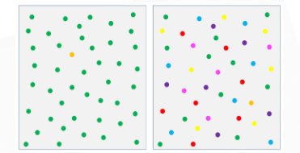
3.4 Attention to objects

Features must be bound to make up an object
Feature integration theory : attention acts as a cognitive glue that binds features that make up a single object.
Different sensory features are coded by specialised independent sub systems or modules. Each module forms a feature map
Detection of these features are represented on different maps in parallel without the need for attention
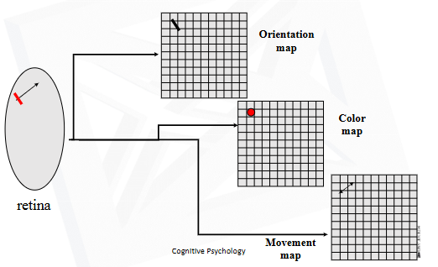

When a conjunction of features is required then the separate features are combined, and this combining requires focused attention
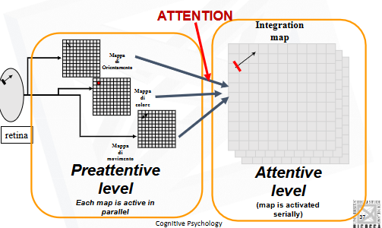

A conjunction of features to form an object can be achieved in three ways :
- Encoded features on feature maps are fit into predicted object frames according to stores knowledge (Top down influence)
- Attention may select within a master map of locations that allow all features at a particular location to be gathered together. This creates a temporary representation of the combination of these features in an object file
The contented of this object file are then used to recognize the object by matching it to stored knowledge in memory
- Features may combine on their own without attention but sometimes be inaccurate and give ride to an Illusionary conjunction

